**Dashboard:** 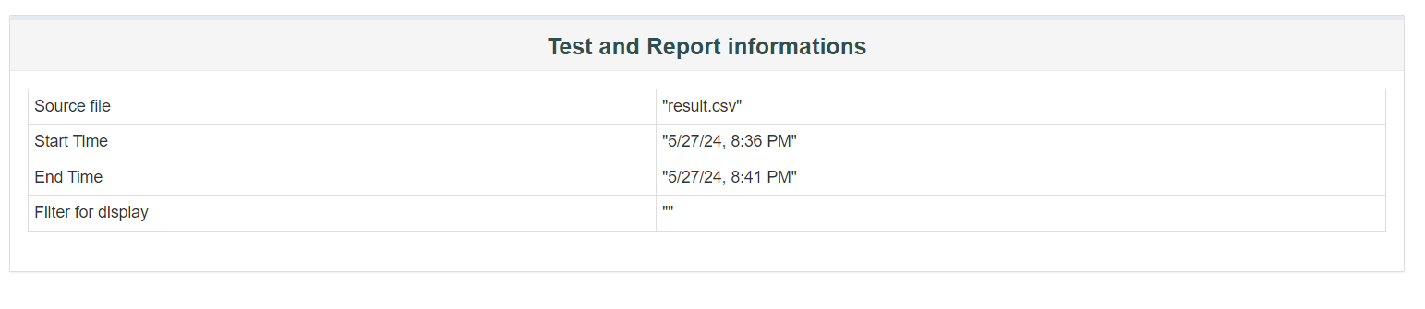

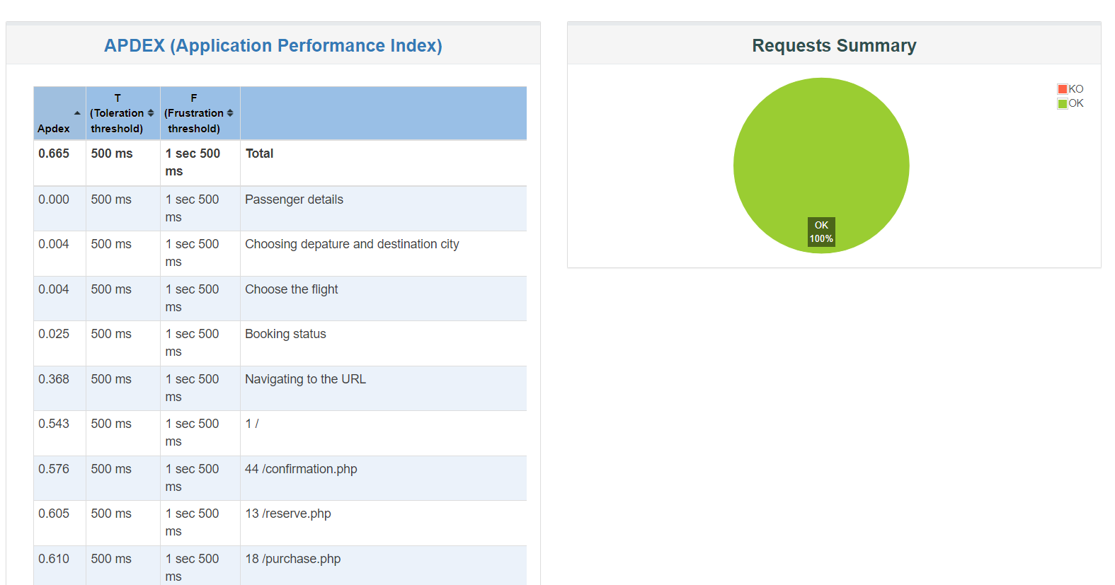

**Errors:**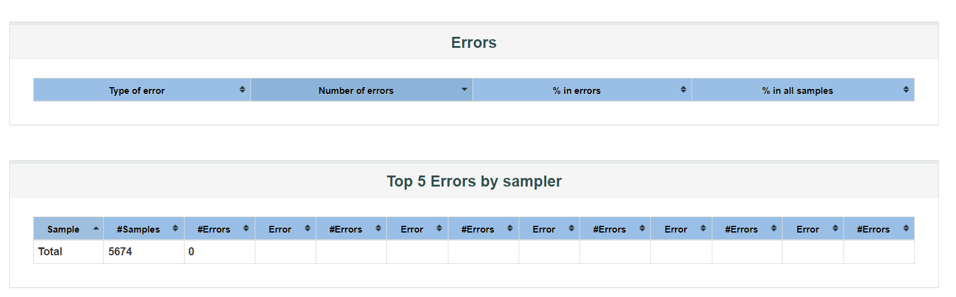

**OverTime:**

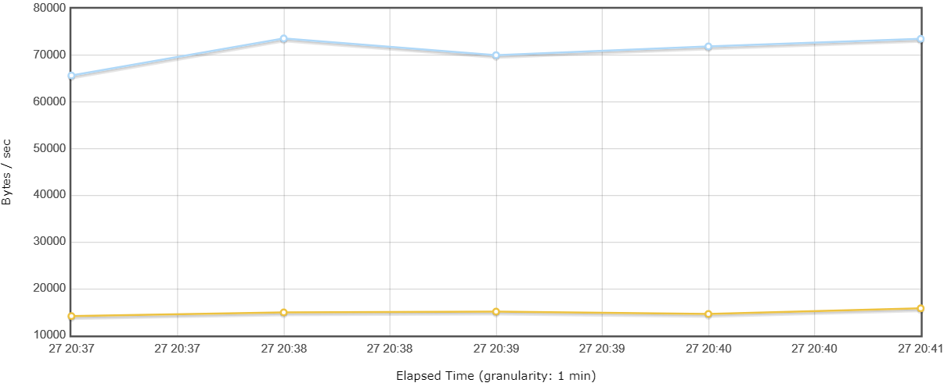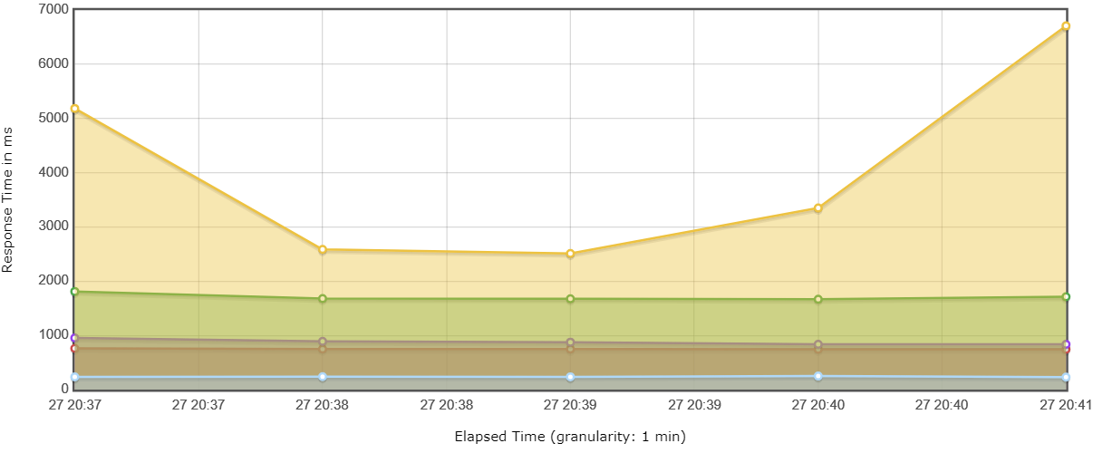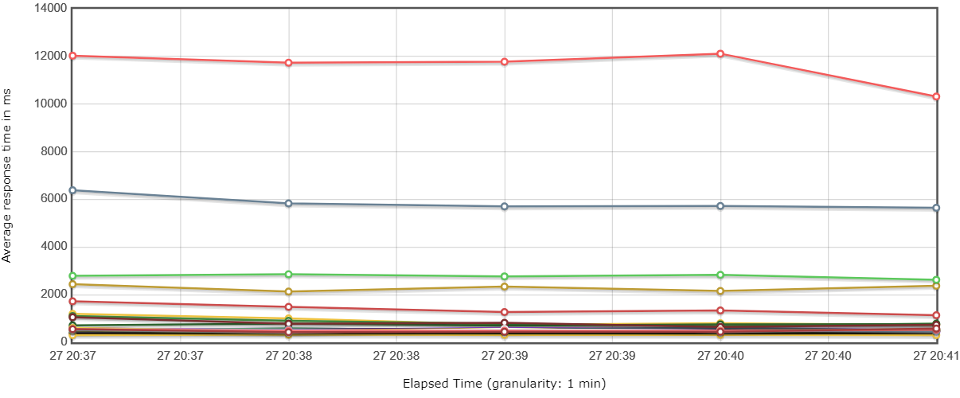

**Response Time:**

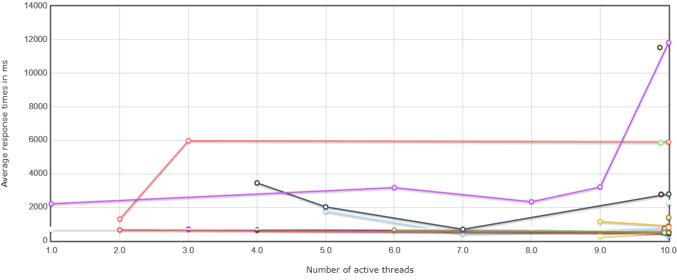

**Throuhput:**

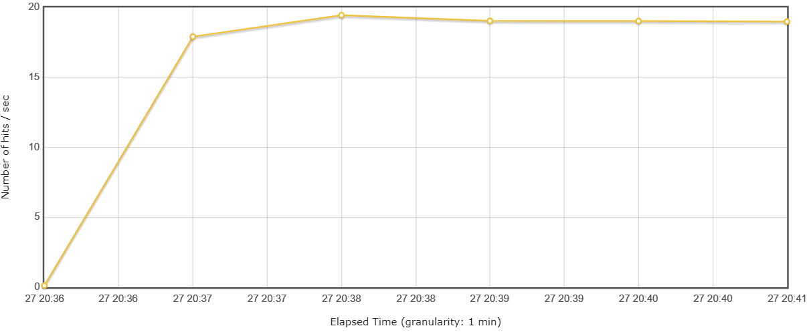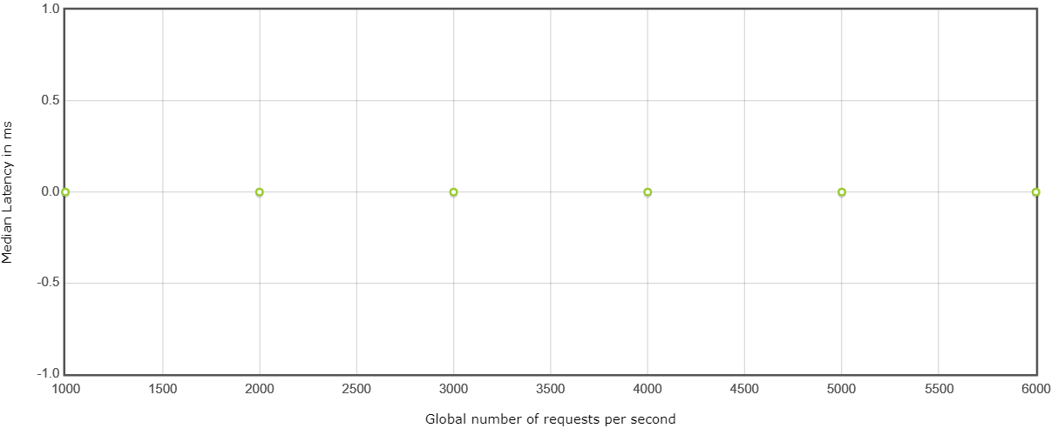

**Custom Graph: Over Time**

